Civil Rights Movement
Name
Institution of Affiliation
Course Name and Code
Date
Civil Rights Movement
The Civil Rights Movement was an organized effort by Black Americans to emancipate themselves from racial prejudice and discrimination. They sought to get themselves equal rights under the law with other people in the United States. The movement began in late 1940s and bore fruits in late 1960s. The following is a timeline of the events that occurred during the movement:
- Executive order from President Truman to end segregation in the armed forces- July 26, 1948
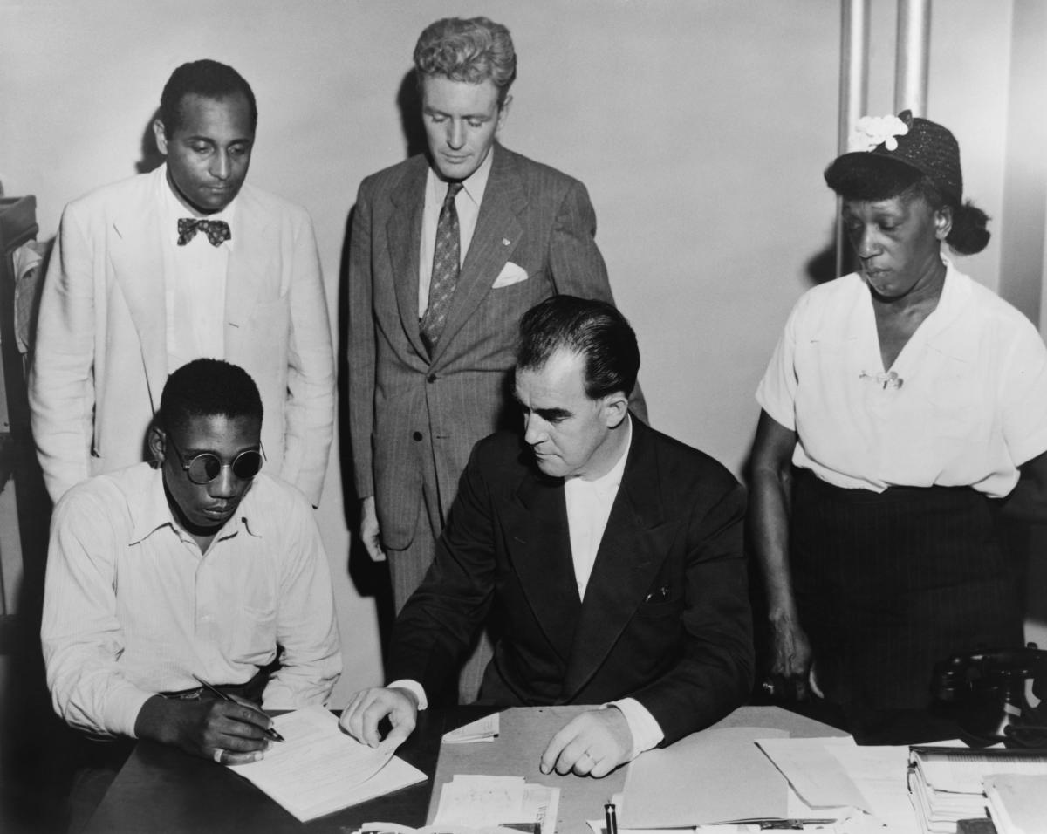
- Brown v. Board of Education: consolidation of five supreme court cases to end segregation in public schools- May 17, 1954
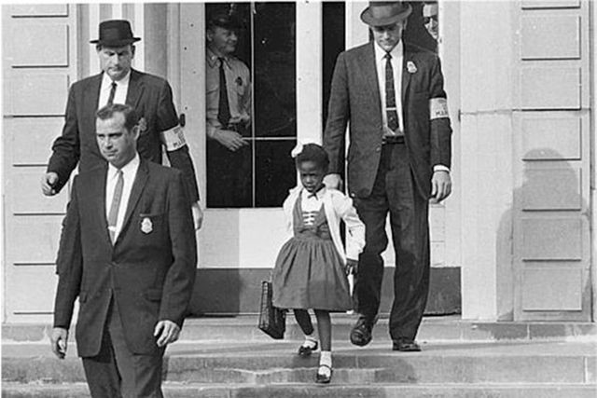
- Rosa Parks and the Montgomery Bus Boycott- December 1, 1955
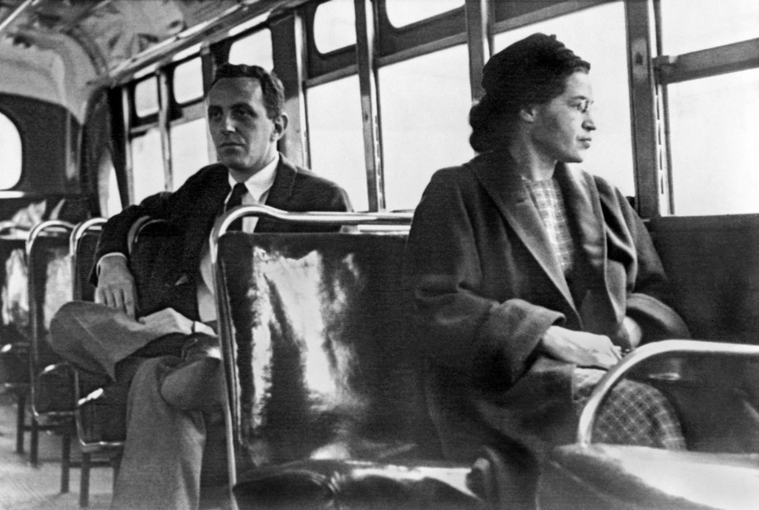
- Integration at the Little Rock Central High School- September 4, 1957
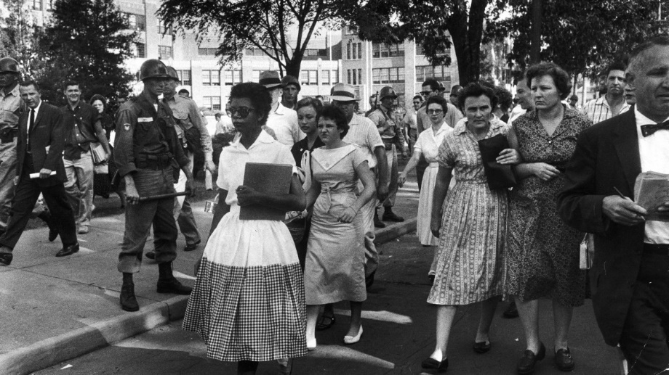
- Civil Rights Act of 1957- September 9, 1957
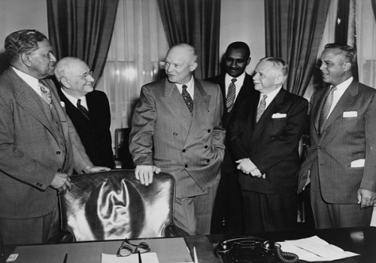
- The Greensboro Four and the Sit-In Movement- February, 1960
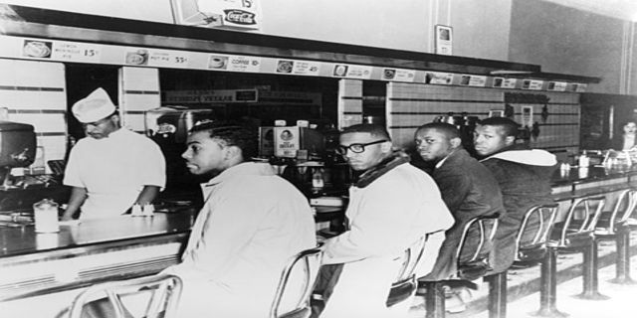
- Ruby Bridges and the New Orleans School Integration- November 14, 1960
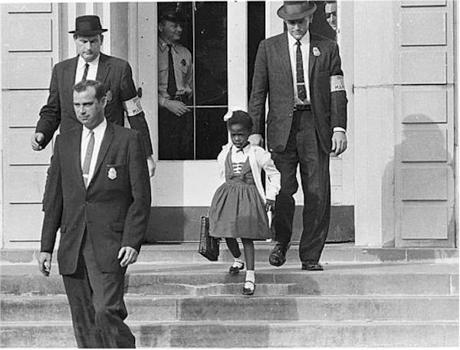
- Freedom rides- May 4, 1961
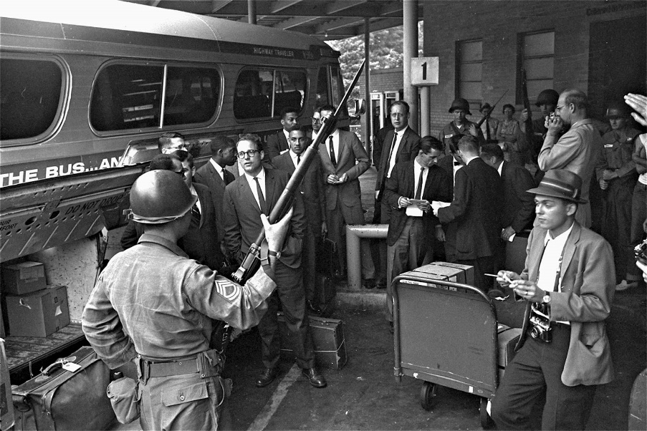
- Birmingham Demonstrations- June 11, 1963
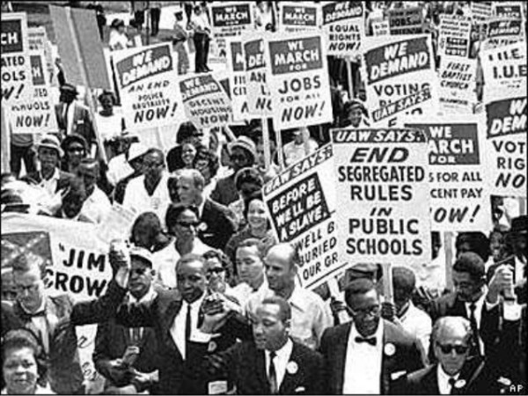
- March on Washington- August 28, 1963
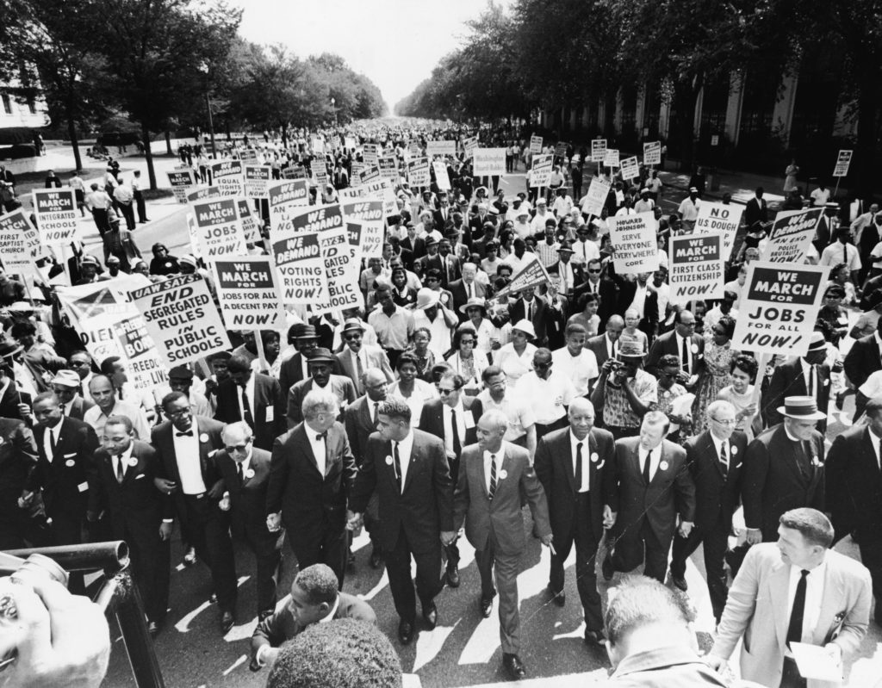
- Signing of Civil Rights Act- July 2, 1964
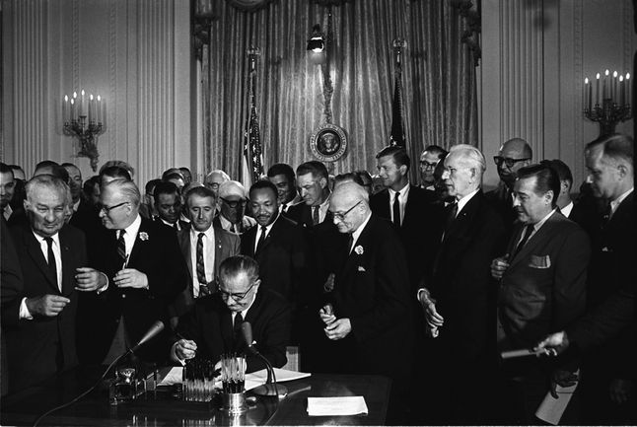
- Assassination of Malcolm X- February 21, 1965
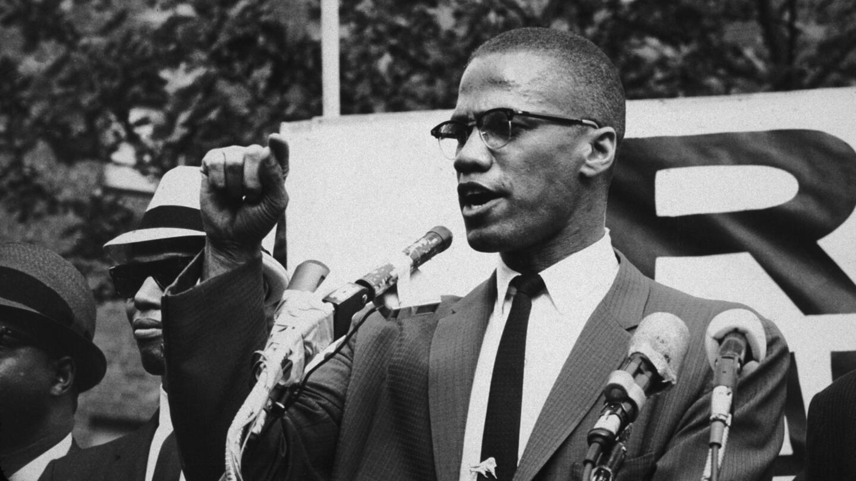
- Authorization of Interracial marriages; loving v. Virginia – June 2, 1967
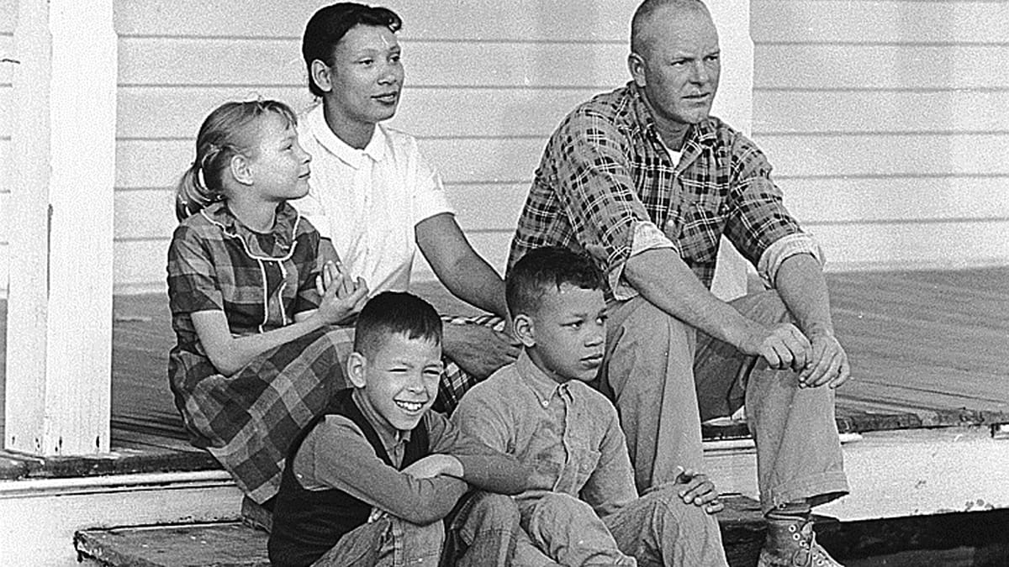
- Assassination of Martin Luther King, Jr. – April 4, 1968
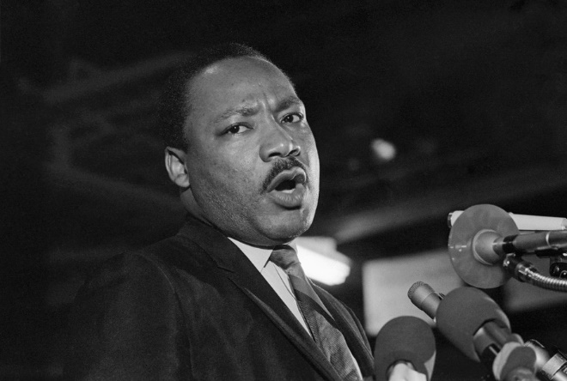
Regardless of whether an event in the Civil Rights Movement was a success or failure, each of them was significant and served the greater purpose of Black emancipation. The executive order by President Harry Truman showed his commitment to the emancipation course by abolishing segregation in the armed forces. Black soldiers could now be promoted to higher ranks. In the Brown v. Education Board case, segregation in public schools was dubbed unconstitutional. However, several schools continued to discriminate against people of color (Blair and Michel, 2000). The ruling also implied that segregation in other public facilities was unconstitutional.
The bus boycott in Montgomery was a significant success in the civil rights movement. Rosa Parks refused to give up her seat to a white passenger in a public bus. Her subsequent arrest caused boycott of the public transport system and protests that were led by Martin Luther King Jr. The boycott continued for a year until the supreme court ruled the segregation in the public buses to be unconstitutional. Attempts by the Little Rock Central High School to integrate black students were met with violence. Despite continued harassment of the students, eight out of nine completed their academic year. The civil rights act of 1957 reinforced the fight against segregation. The act authorised segregation of those who suppressed the voting rights of others. The sit-in movement in Greensboro Woolworth’s pushed other facilities to start desegregating. The admission of Ruby Bridges to an all-white school was another contribution to the fight against segregation (Brunner and Haney, 2007). Many white parents removed their children from the New Orleans school while expressing their disapproval of integration. However, Ruby continued to attend the school and her bravery inspired Norman Rockwell painting, “The Problem We All Live with.”
The freedom rides facilitated the ban of segregation by the Interstate Commerce Commission. Both African American and White individuals were involved in this event, which showed the support of the white people in the struggle against segregation. The demonstrations in Birmingham led by Martin Luther King Jr. managed to lobby for local reforms in undermining racial segregation. The demonstrators were treated with hostility as seen in the arrest of Martin Luther King Jr. for violating an anti-protest injunction. The March on Washington was a success in protesting against abuse of civil rights and employment discrimination. This led to the signing of civil rights act into law in 1964. Discrimination in the use of public facilities, voting and employment was prohibited. Malcom X was an avid activist in the movement and demanded progression beyond civil rights to human rights. His speeches rallied for black nationalist ideology. Unfortunately, he was assassinated in his quest for the black power movement. Authorization of interracial marriages in the case of Loving and Virginia, enhanced racial equality with people of different races being allowed to marry (Britannica, n.d.). The civil rights movement culminated in the assassination of martin Luther King Jr. He had been the face of the movement and is attributed with most of its successes.

References
Blair, C., & Michel, N. (2000). Reproducing civil rights tactics: The rhetorical performances of the Civil Rights Memorial. Rhetoric Society Quarterly, 30(2), 31-55.
Britannica, (n.d.). Timeline of the American Civil Rights Movement. Retrieved from https://www.britannica.com/list/timeline-of-the-american-civil-rights-movement
Brunner, B., & Haney, E. (2007). Civil rights timeline. Retrieved on August, 18, 2013.

